10km Series

Olympic Park Course Description

Prepared and measured by Stephen Jackson

Course Overview
NEW: P5 Parking Area off Hill Rd near Holker Busway
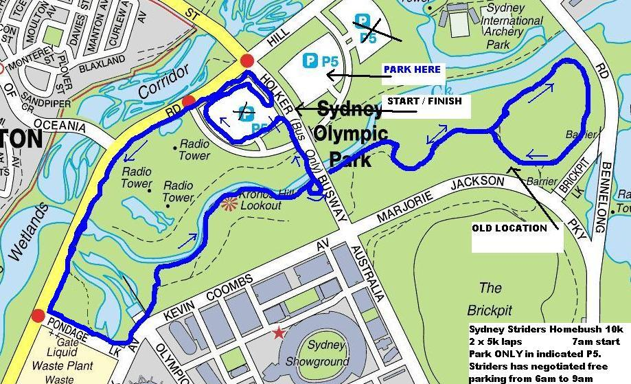

Our newer newest course. Toilets, water, garbage bins, and shelters are at the start. The course is twice around a traffic free 5k loop, starting and finishing at the P5b Parking area off Hill Rd, near the Holker Busway. NOTE: Holker Busway is buses only - access is via Hill Rd. Striders has negotiated FREE parking in P5c (check the map) from 6am to 9am. Parking in any other P5 areas will cost you $3 per hour, and staying in P5cafter 9am will also cost you $3 an hour from when you arrived....

In Detail
The start, 5k, and finish is at the P5b Parking Area facilities on Holker Busway, off Hill Rd. The START is in the westerly P5b parking area.

Run a clockwise lap of P5a carpark, exiting onto the footpath along Holker Busway halfway back up the small hill. Turn left on the footpath, then left at the bottom and run along Hill Rd footpath.

1km Continue to Pondage Link and turn left. (Note, do not take the left hand path before Pondage Link - that is the old course) Keep the grassy knoll at the corner of Hill Rd and Pondage Link on your left. Left at Kevin Coombs Ave, then veer left into the parkland just past the fountains. (2km just into parkland)

Follow the bike path keeping left, pass under Holker Busway, continue over concrete bridge (3km at start of bridge) to Wentworth Common, turning left for a lap.

4km at toilet block path.
Finish the lap, turn left into the path you came out of earlier, follow the bike path back to Holker. Just after going under Holker take the hard left hand U turn up onto the bridge.
Continue along the bridge footpath and veer left as you pass the amenities block 5km. Back through the start line.

Repeat.

At the end of the second lap do not veer left, just run straight ahead to the finish shute - it will be abundantly clear when you get there!

Parking: Just remember to park in P5c - not the other P5 areas - there will be signs and a marshal to point you at the correct area.

