The Barrenjoey Bash

START Beach Reserve, Surfview St, MONA VALE
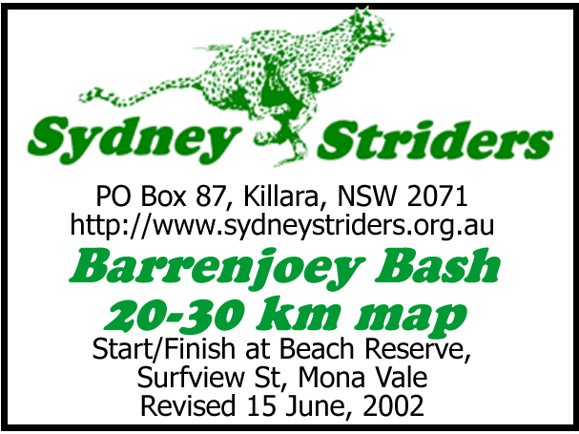
0.0 north along Surfview
0.3 R into path through Mona Vale Headland Res.
0.6 L Up steps (Bicentennial Walk) to lookout
1.0 follow Hillcrest
1.5 R Barrenjoey
1.9 R Karloo Pde
2.4 R Bungan Head Rd around headland
3.3 R Myola, across Newport Beach Res. into car park
4.2 north on track from car park up steps to headland
(Bicentennial Walk). Follow to Bilgola Beach.
5.4 L Bilgola Ave then R Serpentine
5.8 L cross Barrenjoey Rd into Old Barrenjoey Rd
6.7 R Avalon Pde
6.9 cross Barrenjoey Rd into beach car park. Go north through park.
7.3 water/toilets at cnr Tasman + Central **Short Option A**
7.5 north along Tasman

SHORT OPTION A

Subtracts 15.5 km. 14.4 km total.
- Turn around. Back thru reserve.
cross Barrenjoey.
0.5 R Avalon Pde
0.6 L Old Barrenjoey
[Rejoins long course at 23.4 km]
8.1 L North Avalon
8.2 R Binburra
8.5 L Burrawong (1st left) then R Whale Beach Rd
10.6 **Short Option B**
10.6 continue along Whale Beach Rd past Whale Beach
12.4 R down Pegasus steps (cnr Whale Beach + Florida)
12.7 L along Ocean Rd to SLSC (water/toilets)
13.2 contine along Ocean Rd
13.6 R Gov. Phillip Park. Run to end of sealed road then follow loop road back
15.0 R Beach Rd
15.2 L Barrenjoey Rd
15.6 L Palm Beach Rd

SHORT OPTION B

Subtracts 7.6 km. 22.3 km total.
0.0 L Surf Rd. Over hill.
0.3 [Rejoin long course]

15.8 R Pacific Rd. Stay on Pacific (not Ralston).
16.8 R Ebor (water at No. 14)
17.1 L Cynthia
17.6 R Bynya
18.5 R Surf **Short B rejoins**
18.8 L Barrenjoey
19.4 R Currawong to waterfront then turn left
19.7 cross Etival, thru trees to Careel Bay playing fields
20.0 water/toilets. Continue through playing fields on path to R of tennis courts. Cross footbridge.
20.7 into Elvina Ave
20.9 R George
21.5 L Therry then L Queens
22.3 R Elvina
22.5 L Wollstonecraft
22.8 R Barrenjoey Rd, thru Avalon shops, past primary school. **Short A rejoins**
24.0 R up steps and R into Plateau Rd
24.8 L The Outlook
25.0 L Wollombi Rd, to Water Reservoir
25.3 take path alongside left fence around water tanks. Down hill on gravel path.
25.6 down Attatunga Rd
26.3 R Barrenjoey Rd, thru Newport shops (water/toilets at servo). Stay on Barrenjoey.
28.9 L Grandview

29.1 R Orana, then L Bassett and R Surfview
29.9 FINISH


