Middle Harbour Picnic

Highlights: Views from Panorama Pde, Parriwi Rd and the Esplanade (Balmoral).
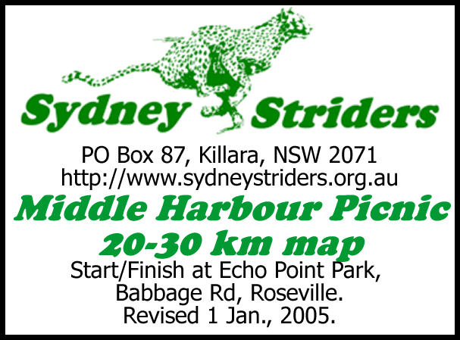

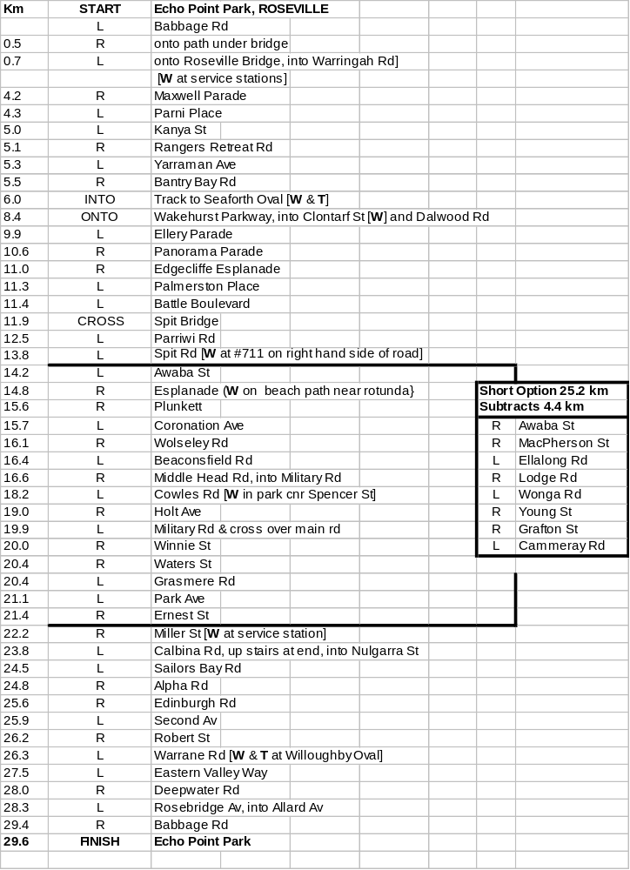Pains: Awaba St, Warringah Rd, Parriwi Rd, Coronation Ave, Hole Ave and sundry other spots.



